FOR IMMEDIATE RELEASE

(INSERT NAME) Partners With
“National Haunted House Day” Campaign

At a glance:
- Haunted attractions leaders, (INSERT NAME), has given its support to mark the second Friday in October as “National Haunted House Day”
- Proposed day of observance is set to celebrate the haunted, paranormal and supernatural community

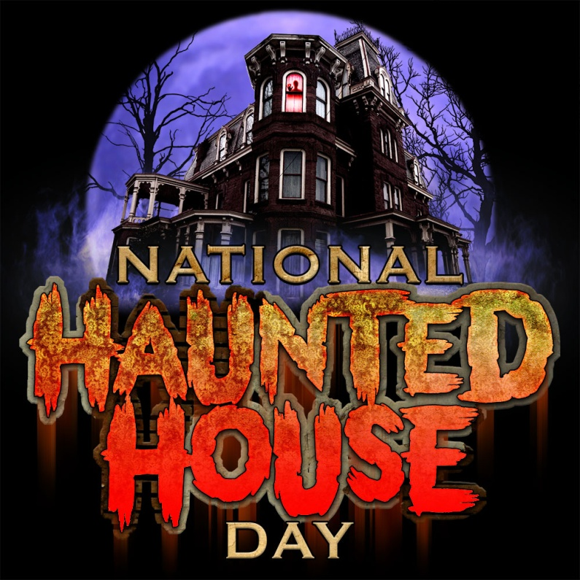
(INSERT DATE) (CITY) – (INSERT NAME) has announced its intention to support a day of observance for the haunted house industry. Simply titled, “National Haunted House Day,” the organization hopes to establish the second Friday in October as a day to celebrate and recognize the benefits of the haunted house industry, to fans, proprietors, and civic leaders.
The proposed day of observance will bring the country’s haunted, paranormal and supernatural community together to celebrate the season and provide needed funds to charities nationwide.
A petition to recognize the day has been launched on “We The People,” the White Houses’ official site for petitions nationwide.
In addition to advocating for a national day of observance for the haunt industry, (INSERT NAME) will also donate (INSERT DONATION) to the campaign.
For more information on “National Haunted House Day,” please visit www.nationalhauntedhouseday.org. To sign the petition to make “National Haunted House Day” a reality, please visit https://petitions.whitehouse.gov/petition/name-second-friday-october-national-haunted-house-day/ZCgxYpbP

-MORE-

About National Haunted House Day
Haunted House Attractions are widely attended during the month of October by millions of Americans, who collectively generate billions of dollars in revenue and have a positive effect on the U.S. economy each year.

Our mission is to establish “National Haunted House Day,” recognizing haunted houses and their contribution to small business, job creation and the arts. “National Haunted House Day” not only recognizes the haunt industry, but additionally serves as a conduit of fundraising for charitable projects and community foundations.

As artists, business owners, community leaders and as a united family sharing a common vision and passion for an industry, we ask that NATIONAL HAUNTED HOUSE DAY be declared by the White House and recognized each year on the SECOND FRIDAY IN OCTOBER.

###

