Name: [TYPE YOUR NAME HERE]
Date: [TYPE YOUR TITLE HERE]
Title: [TYPE YOUR TITLE HERE]

Dear Congressman or Congresswoman:

I am a member of a...

- $500,000,000 year industry that creates over…*
- 250,000 jobs annually and supports….*
- A major economic engine that consumers spend over $7,000,000,000 on annually during the Halloween season - including candy, costumes, and entertainment *
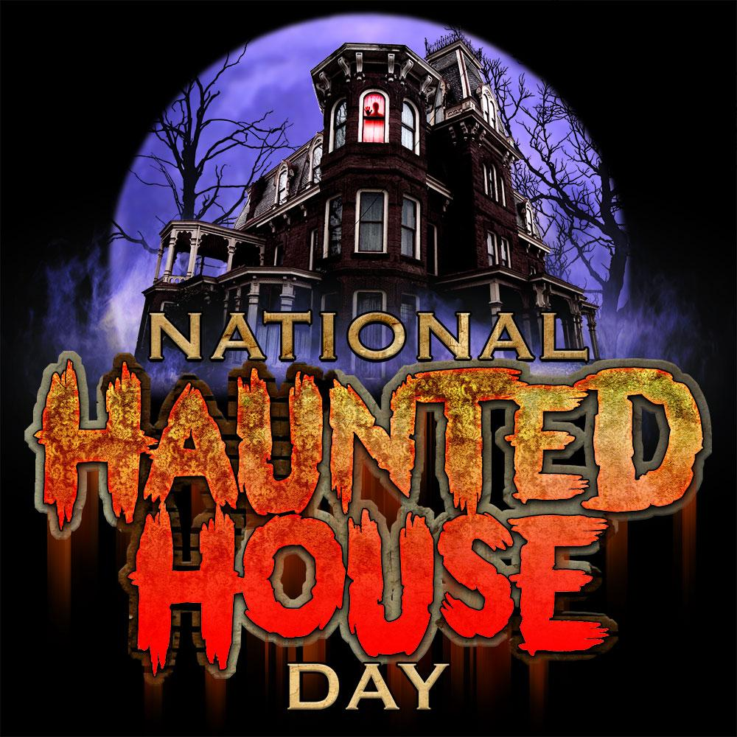
On behalf of my industry and my local business, I request your support of the proposed National Haunted House Day.

My industry and I aim to raise money for charitable projects and foundations in your district serving our community by donating a portion of our proceeds from sales generated on the second Friday of October.

As a citizen of your District, a member of our community, as a business owner and proponent of charitable programs, I ask that you, your office, and the district endorse the implementation of National Haunted House Day on the Second Friday in October.

Our Mission

Haunted House Attractions are widely attended during the month of October by millions of Americans collectively generating hundreds of billions of dollars in revenue and sales. Our mission is to establish a locally and federally observed holiday recognizing haunted houses on the second Friday of October that serves as a conduit of fundraising for charitable projects and community foundations.

As artists, as business owners, as community leaders, as charitable leaders, as a united family sharing a common vision and passion for an industry we stand up and ask that members of congress adopt legislation to enact a proposition that makes National Haunted House Day an officially observed day on the second Friday in October.

We further insist that haunted house producers across the country contribute to charitable causes on National Haunted House Day by donating a portion of their proceeds to a charity or nonprofit of their choice.

A Brief and Current History

Bobby Pickett recorded Monster Mash in 1962. In 1982 Michael Jackson filmed Thriller. Individuals like Pickett and Jackson paved the way for the broader celebration of halloween festivities and of the horror genre through music and film in their own generations. They forever impacted popular culture in October and evolved the way in which people celebrate a Holiday, and the culture around it, that is only second to Christmas in scope and scale...Halloween.

Since those generations the month of October has witnessed yet another shift in popular culture. The relationships people have with Halloween and horror and the way they choose to celebrate them has evolved yet again with the rise in popularity of the modern day Haunted House.

In recent history, over the past few decades at least, Haunted Houses have been slowly and methodically extending the celebration of Halloween and Horror well beyond a single night in October. For weeks and even months leading up to Halloween people can now visit a local haunted house event and get a full helping of ghouls, ghosts, and monsters, thrills and chills, sights, and frights in a unique and dynamic way. Haunted House events feature monsters, characters, decorations, and themed entertainment typically opening from Mid September and operating through October. Attending haunted houses has become a staple “to do” for over 55,000,000 across the country during that time of the year.

While haunted houses may vary from one attraction or event to the next they all have at least one thing in common. Haunted Houses invite their guests into a thematic world of entertainment that is based in the realm of Halloween, horror, or some combination of both. Groups of people show up and are entertained as they move through these worlds and are most often scared in a fun way along their journey.

Commercial haunted houses today are huge productions featuring hundreds of characters, special effects, scenic environments, and sets that rival television and film in production value. The largest of America’s haunted houses are multi million dollar productions attended by hundreds of thousands of people in a season. Haunted Houses continue to be a growing part of the Halloween economy and event industry and now is time for the next step.

It is Time for Action

The growth in popularity of Haunted Houses has inspired us as producers of these events. This impact on popular culture has humbled us as members of the Halloween and Horror industries. This tradition has united us as members of our own communities. And now we stand up together.

As stated in our mission we are artists, business owners, community leaders, charitable leaders, and a united family sharing a common vision and passion for an industry. We stand up together and ask that members of congress adopt legislation to enact a proposition that makes National Haunted House Day an officially observed day on the second Friday in October.

We further insist that haunted house producers across the country supporting this holiday contribute to charitable causes on National Haunted House Day by donating a portion of their proceeds on the second Friday in October to a charity or nonprofit of their choice.

From Bobby Pickett to Michael Jackson, from music to film and everyone and thing in between we too have impacted popular culture in a permanent way. Unlike Pickett and Jackson we have not done this as individuals or with a single piece of art, rather as a collective, and as a total industry. We seek to use that impact in a meaningful way in our communities by supporting charitable projects and foundations through the adoption of National Haunted House Day.

Sincerely,

[TYPE YOUR NAME HERE]
[TYPE YOUR TITLE HERE]
[TYPE YOUR ORGANIZATION NAME HERE]

